

AWS Terminology and services

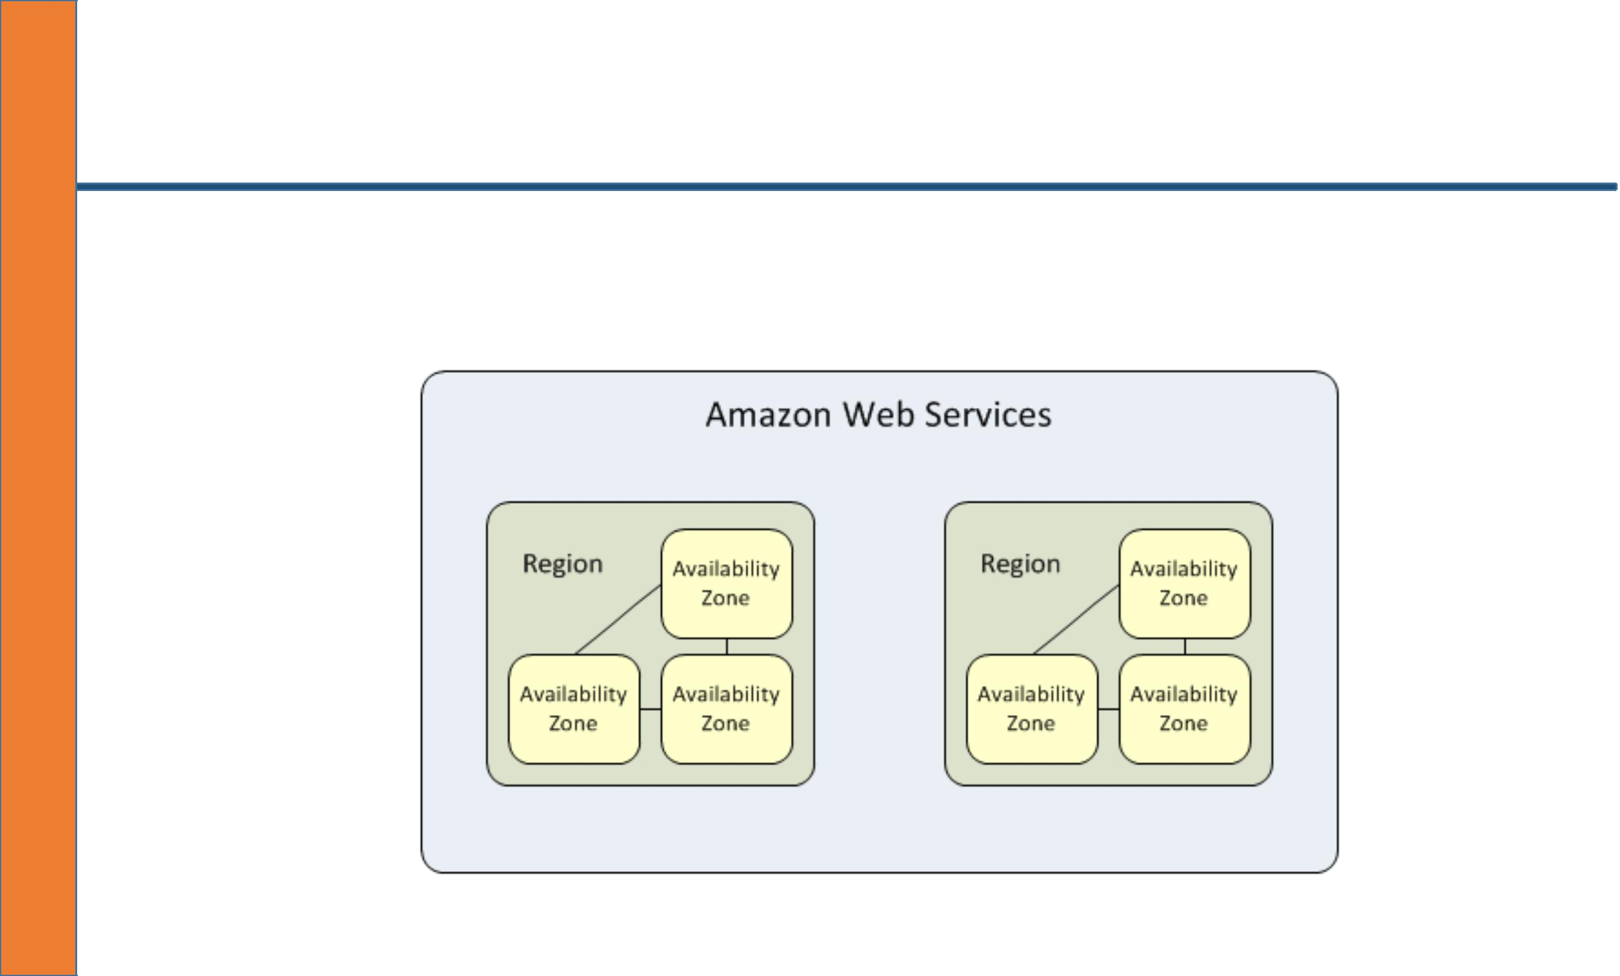
WHAT IS AN AMAZON AWS REGION?

- An Amazon AWS region is a physical location spread across globe to host your data to reduce latency. In each region there will be at least two availability zones for fault tolerance.

WHAT IS AN AMAZON AWS AVAILABILITY ZONE?

- An AZ is a combination of one or more data centers in a given region.

- These datacenters need not to be separated by multiple kilometers physically but by meters with in a physical compound which are completely isolated from each other failure such as power, network in a given AZ.

- it is a logical grouping of data centers in a given region for service high availability.

- These AZs in a region are connected with direct Fiber optic links which have capacity of around 25Tbps bandwidth and a latency of 2ms to 1ms.

WHAT IS AN AMAZON AWS DATACENTER?

- A datacenter is a location where actual physical data resides.

- A data center typically have 50000 to 80000 physical servers.

- A single or couple of data centers are clubbed in to one AZ.

WHAT IS AN AMAZON AWS EDGE LOCATION?

- An edge location is where end users access services located at AWS

- They are located in most of the major cities around the world and are specifically used by CloudFront (CDN) to distribute content to end user to reduce latency.

- It is like frontend for the service we access which are located in AWS cloud

WHAT IS AN AMAZON AWS DIRECT CONNECT?

An Amazon AWS direct connect is a service offered by Amazon for a dedicated optical fiber cable from your office premises to Amazon AWS cloud where you run your applications.

The advantage of this service

1. one is to provide adequate and dedicated bandwidth to your services located in AWS

2. reduce latency from your network to AWS network

3. provide private connectivity to your services in AWS from your office network.

WHAT IS AWS ENDPOINTS?

- An AWS endpoint is a URL we try to connect to our AWS web console to access our services to configure them.

Terminology

Scalability:

Ability for a system to expand and contract according to workload demands

- Resilient

- Operationally efficient

- Cost effective as the service grows

Fault Tolerant:

Ability for your system to operate without interruption in the event of service failures §

- Auto Scaling

- Route 53

- Availability Zones

- Multiple Regions

Elasticity

Fundamental property of the cloud; the ability for an infrastructure to adapt up and down automatically to a given work load.

Proactive Cycle Scaling:

Scale out based of “known” peak periods

Proactive Event-Based Scaling:

Scale out in anticipation of increase demand

Auto-Scaling Based On Demand:

Scale out based on metrics such as CPU utilization, network utilization etc. This is considered horizontal scaling VS vertical scaling.

AWS Services

AWS Services are grouped in the following categories

- Compute and Networking
- Storage and Content Delivery

- Database Services

- Analytics

- App Services

- Deployment Services

- Management Services

Compute and Networking Services

AWS provides a robust offering of compute and networking services. These services have different use cases depending on your application type, build, and deployment method.

Compute and Networking
- EC2 (Elastic Compute Cloud)

  - Auto Scaling

  - Elastic Load Balancer

  - EBS Volumes

- Virtual Private Cloud

- Amazon Route 53

Amazon (EC2) Elastic Compute Cloud

Amazon EC2 provides scalable virtual servers in the cloud. The virtual servers can run different operating systems but most commonly run a flavor of Linux or Windows.

An EC2 virtual server is known as an “instance” and can be made up of different instance types and sizes.

Pricing Models

- Reserved Instances

- On-Demand Instances

- Spot Instances
Instances Types

Reserved Instances:

Allow you to reserve Amazon EC2 computing capacity for 1 or 3 years, in exchange for a significantly discounted hourly rate (up to 75%)

On-Demand Instances:

Are used “on-demand” and are paid for by the hour. If you only need an instance for an our only fire it up for that long!

Spot Instances:

Allow you to bid on unused Amazon EC2 capacity and run those instances for as long as your bid exceeds the current Spot Price.

Auto Scaling

- Auto Scaling is a service and method provided by AWS in order to increase the number of instances on-demand based on certain metrics.

- if your application demand increased un-expectantly auto scaling can scale up to meet the demand and then s top instances as soon as the demand decreases.

- This is known as “elasticity” in the AWS environment.

Elastic Load Balancing

- Load balancing is a common method for distributing traffic among servers in the IT environment.

- The Elastic Load Balancer is another service by AWS EC2 that allows you to add instances to the elastic load balancer and dis tribute traffic among those instances.

- The elastic load balancer can send traffic to different instances in different availability zones and should often be used with auto scaling and designing for fault tolerance.

Route 53

- Route 53 is a domain management service by AWS. Route 53 will host the internal and external DNS for your application environment

- It is used commonly with ELB to direct traffic from the domain to the ElB

AMI & EBS

- AMI: Amazon Machine Image is a template that contains a pre-built software configuration. Amazon Machine Images are used with Auto Scaling and Disaster recovery

EBS Backed Instance (Elastic Block Store)

- provides persistent block-level storage volumes for use with Amazon EC2 instances in the AWS cloud

- Each Amazon EBS volume is automatically replicated within its Availability Zone to protect you from component failure, offering high availability and durability.

- With Amazon EBS, you can scale your usage up or down within minutes—all while paying a low price for only what you provision.

- Can be as small as 1GiB and 16,384GiB (16Tib) in size.

- Cannot Be Attached To Instance In A Different Availability zone

- Allows for point In Time snapshots

Virtual Private Cloud

- VPC lets you provision a logically isolated section of the AWS cloud where you can launch AWS resources in a virtual network that you define.

- You have complete control over your virtual networking environment, including selection of your own IP address range, creation of subnets, and configuration of route tables and network gateways.

- Resources fired up in a single VPC will be part of the same network and can communicate internally.

- VPC does not cost only the resources within the VPC are what costs

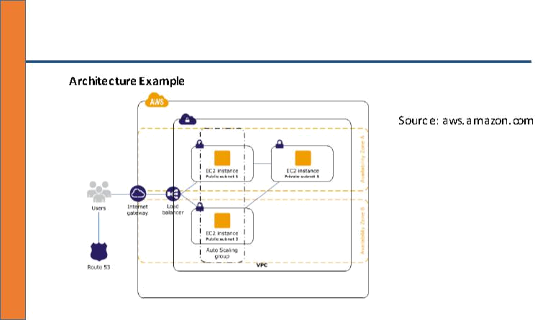

Storage and Content Delivery

- Amazon S3

- Glacier

- Amazon Storage Gateway

- Amazon Import/export

Amazon S3

Simple Storage Service (S3) is a object storage service from AWS

- Amazon Simple Storage Service provides developers and IT teams with safe, secure, and highly-scalable object storage .

- It has a simple web service interface for storage and retrieval of any amount of data from anywhere on the web.

- Enable versioning, and lifecycle policies, but it can also serve static HTML files with Route 53.

- Designed for “11 nines” (99.999999999%) durability and 99.99% “availability”

- Charges based off of per gig storage as well as data sent out of the region

- Data transfer from S3 to an EC2 instance within the same region is free

- Bucket names are unique across the entire S3 design (all regions included)

Glacier

- a secure, durable, and extremely low-cost storage service for data archiving and long-term backup.

- Used for data not frequently accessed

- Amazon Glacier is optimized for infrequently accessed data where a retrieval time of several hours is suitable.

- Integrates with Amazon S3 lifecycle polices for easy archiving

AWS Storage Gateway

- Connects local data center software appliances to cloud based storage such as Amazon S3

Amazon Import/Export

- AWS Import/ Export gives the ability to take on-‐premise data and physically snai mail it to AWS.AWS will import he data to either S3, EBS, or Glacier within one business day of the physical device arriving at AWS.

Benefits:

- Off-Site Backup Policy

- Quick Migrate LARGE Amount of data in to cloud.

- Disaster Recovery

Amazon Web Services Databases

- Relational Database Service (RDS)

- Amazon ElastiCache

- Amazon DynamoDB

- Amazon Redshift

Amazon RDS is a fully managed database service for relational databases. This means that access to the underlying OS is not allowed and software patches and management are handled by AWS.

Databases Supported by RDS

- MySQL

- PostgreSQL

- Oracle

- SQL(MS SQL Server)

- Aurora

Aurora :Home grown Relational Database forked, and fully compatible with MySQL. It has fives times better performance then MySQL and a lower price point than commercial databases.

Amazon ElastiCache is a web service that makes it easy to deploy, operate, and scale an in-memory cache in the cloud.

- The service improves the performance of web applications by allowing you to retrieve information from fast, managed, in-memory caches, instead of relying entirely on slower disk-based databases.

- ElastiCache supports two open-source in-memory caching engines:

  - Memcached

  - Redis

Amazon DynamoDB is a fast and flexible NoSQL database service provided by aws.

Fully managed NoSQL service

- Service manages all provisioning of underlying hardware

- Fully distributed and scales automatically

- Built as a fault tolerant highly available service

- Primarily used by developers

Amazon Redshift is a fast, fully managed, petabyte-scale data warehouse service that makes it simple and cost-effective to efficiently analyze all your data using your existing business intelligence tools

Analytics (EMR)

Amazon Elastic MapReduce (EMR) Elastic MapReduce is a Hadoop clustering tool that makes it easy to manage and integrate with Hadoop clusters.
- Hadoop is used for big‐data analytics and through Elastic MapReduce.

- It can integrate easily with other services such as Redshift and DynamoDB for data analytics

APP Services

- Amazon Simple Work Flow Service (SWF)

- Amazon Simple Queue Service (SQS)

- Amazon Simple Notification Service (SNS)

Amazon Simple Work Flow Service (SWF)

- Track work flow executions

- AWS control panel ability to monitor task work flow

- Consistent execution

- Scalable parallel EC2 processing

- Service can be used with on premise servers

- Guarantees execution of work flow

Amazon Simple Queue Service (SQS)

Amazon Simple Queue Service (SQS)

- Decouple infrastructure systems

- Auto scale based off queue size

- Guarantees delivery of “at least” 1 message but does not guarantee no duplicates

- Scalable and highly available by design

- Does not guarantee message order but does attempt “best effort” order delivery

Amazon Simple Notification Service (SQS)

Coordinates and manages the delivery or sending of messages to specific end points.

This service can be used for publishing IOS/Android app notifications, gluing together automation based off of sent notifications

End points

- SQS

- Email

- Email json

- SMS

- HTTPS

- HTTP

- Application

Deployment Services

- Elastic Beanstalk

- CloudFormation

Elastic Beanstalk

- Easily deploy complete application environments automatically.

- Integrates with the Elastic Load Balancer, Auto Scaling, EC2, and additional AWS services.

- Key benefit for developers who are building applications but do not have the technical knowledge for building application environments

- Includes basic configurations such as web applications and worker instances

- Support for Docker containers

- Easily deploy “dev/test/qa/production” environments with the EB command line tool which integrates with git repositories.

Amazon CloudFormation

- Everything in AWS is an API accessible through an SDK, Command Line Tools, or the console.

- CloudFormation is a tool that allows you to “code” your infrastructure and deploy resources based off of a pre-‐build template.

- This gives the advantage of easy backup and disaster recovery and even version controlling your AWS infrastructure!

- For example with a template and the template code you can build EC2 instances that belong to an Elastic Load Balancer and a Route 53 entry to your elastic load balancer all with code!

Amazon Management Services

- IAM (Identity Access management)

- CouldTrail

- CloudWatch

- Directory Services

IAM (Identity Access Management )

- Web service that allows managing permissions to AWS resources

- Can define resource level permissions and API call permissions based off user/ group/ resource

- API keys and roles are used to manage access to AWS API to integrate with the SDKs

CouldTrail

- CloudTrail is an API logging service that logs ALL api calls made to AWS.

- It does not matter if the API calls from the command line, SDK, or console.

- This helps when addressing security concerns and even seeing what users on AWS performed certain access in your environment.

CloudWatch

- Used to monitor AWS services such as EC2.

- Integrates very well with EC2 and helps provide centralized logging and performance metrics into instances such as CPU usage, Network Usage and more.



